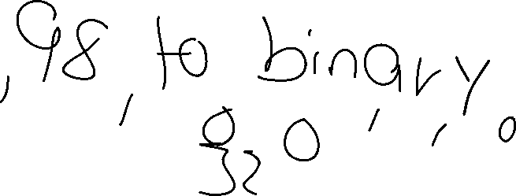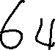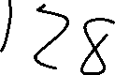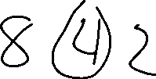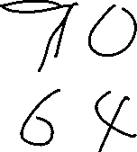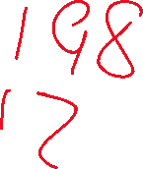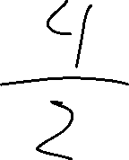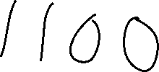

Convert the binary representation: 10001101 to decimal,

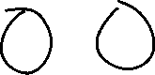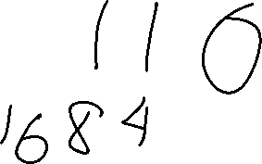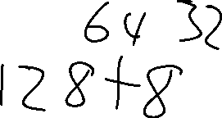

**Data Representation**

Hexadecimal is different from binary and decimal. It uses**base-sixteen**, meaning that there are sixteen different digits that can appear in a single place. Since we only have ten numerals in our shared language, we use the first six Latin letters (A, B, C, D, E, F) to indicate digits 10 through 15

Another number representation system is the binary one, each digit in a binary number is called a bit. Each column of a binary number has twice the weight of the previous column, so binary numbers are base 2.

The decimal numeral system is the most commonly used and the standard system in daily life. It uses the number 10 as its base, also known as radix. Therefore, it has 10 symbols: 0, 1, 2, 3, 4, 5, 6, 7, 8 and 9. The system gives positions to the digits in a number and uses powers of the base 10; digits are raised to the N power, in accordance with the position

The Hexadecimal Color Code #DB0FFF is a contrast shade of fuchsia. RGB Color Model of #DB0FFF consists of 86% red, 6% green and 100% blue . HSL color Mode of #DB0FFF has a 291.00°(degrees) hue, 1.00 saturation and 0.53 lightness. This color has an wavelength of 436.78 nm approximately. #DB0FFF RGB value is rgb(219, 15, 255). The nearest Web Safe Color of #DB0FFF is [**#FF33FF**](https://applecolors.com/color/FF33FF). The Closest small Hexadecimal Code of #DB0FFF is **#D1F**. The most Closest color is